**FPT ACADEMY INTERNATIONAL**



## FPT – APTECH COMPUTER EDUCATION

HAIR CARE

|  |  |  |  |
| --- | --- | --- | --- |
| **Center Name** | | FPT – Aptech – HCM2  Address: 590 Cach Mang Thang Tam, District 3, Ho Chi Minh City | |
| **Instructor** |  | Mr. Le Thanh Nhan |  |
| **Class** |  | T1.2203.E1 |  |
| **Group** |  | 2 |  |
| **Group members** | | **Name** | **Student ID** |
|  |  | Lê Hoàng Thành Phát | Student1372897 |
|  |  | Nguyễn Trần Thế Dân | Student1370225 |
|  |  | Trần Nguyễn Minh Đăng | Student1370232 |
| **Duration** | Start date | 11th June 2022 |  |
| End date | 19th July 2022 |  |

**This is to certify that**

**Mr.:**

Lê Hoàng Thành Phát

Nguyễn Trần Thế Dân

Trần Nguyễn Minh Đăng

**has successfully designed & developed**

eProject: Hair Care website

**Submitted by:**

Lê Hoàng Thành Phát

**Date of issue:**

**Authorized Signature:**



**TABLE OF CONTENTS**

FPT – APTECH COMPUTER EDUCATION 1

ACKNOWLEGMENT 4

SYNOPSIS 4

PROBLEM DEFINITION 4

CUSTOMER'S REQUIREMENTS SPECIFICATIONS (CRS) 4

Business/Project Objective: 4

Hardware/ Software Requirements: 6

SCOPE OF THE WORK (IN BRIEF) 6

Architecture and design of the system 7

Diagram of the website 8

TASK SHEET REVIEW 1 9

SITE MAP 10

MOCK OF THE WEBSITE 11

**1.****HOME PAGE** 11

**2.****PRODUCTS** 12

**3.****HAIR PROBLEMS** 13

**4.****ABOUT US** 14

**5.****BLOG** 15

**6.****CONTACT US** 16

**7.****LOG IN** 17

TASK SHEET REVIEW 2 18

I. WEBSITE DESCRIPTION 19

1. Home page 19

2. Product page 22

3. Hair problems page 24

4. About us page 26

5. Blog 27

6. Contact us 28

7. Login/Register form 29

II. JAVASRIPT DESCRIPTION 30

**1.****Slider - Carousel:** 30

2. Login / Resgister Modal: 31

3. Local Storage: 32

4. Go to Top Button: 33

5. Load JSON: 33

6. Form Search: 33

7. Filter: 34

8. Show modal when click: 34

9. Comparision: 35

10. Scroll into View: 36

11. Form Contact: 36

TASK SHEET REVIEW 3 39

# ACKNOWLEGMENT

On behalf of all the members of group 2, I would like to thank you all for the hard works, supports to make this eProject complete successfully. Especially, Mr. Le Thanh Nhan, our teacher, he helped us a lot from the day that we started to study at FPT Aptech. With this eProject, he has guided us with his enthusiasm and rigorous, because of his guiding, we would be able to finish this project. Besides, I want to thank all the team member of group 2, each of the team member has been working continuously in 4 weeks in order to complete this project. The last but not least, we would like to say thank you to our family for always supporting us, creating the best conditions for us to focus on the project, and putting faith in the dreams we pursue.

# SYNOPSIS

Hair Care is a spa that not only provide hair care products but also knowledge about hair problems. The main purpose of this website is to reach to the customer, who have interest in hair care and looking for good hair care products.

# PROBLEM DEFINITION

Hair Care is a spa which offers not only hair care products but also hair care knowledge and equipments. It caters to almost all the hair problems by providing various lines of product that’s suitable for many hair problems.

Comparison among the same equipment of different companies can be displayed based on availability, cost major features.

The site should include the details as of which companies provide which equipments.

Along with the various equipments, there should also be user manual/guidelines for ease of its use and maintenance.

# CUSTOMER'S REQUIREMENTS SPECIFICATIONS (CRS)

**Client: Hair Care spa**

### Business/Project Objective:

Hair is probably one of the first things you notice about people when meeting them for the first time. This is especially true for women. Beautiful and shiny hair always leaves good impression, which is why proper hair care is important. Also, good care of your hair plays an important part in having healthy hair and helps avoid extensive damage that can lead to hair loss. Regular washing with celebrity advertised shampoos and conditioners is not enough. To have a healthy, strong and shiny hair, you need to know how to care for it daily.

Since the field is really vast, a need is felt that there should be a single platform which will give the complete information of haircare. We are supposed to create a website with the below mentioned requirement specifications.

The website is to be developed for the Windows Platform using HTML5, JavaScript, Bootstrap, jQuery and Geolocation. The site should work well in all leading browsers including Chrome, IE, Firefox etc.

**Input to the system:**

* + - * Searching products, problems, solutions based on suppiler, name, purpose, type of product, …
      * Compare among the same equipment of different companies can be displayed based on availability, cost major features.
      * Register members on website.

**Output from the system:**

* A menu that will categorize all the functions of the site.
* Display the list of available products and problems category wise.
* Categories can be many types of hair care product. E.g there can be shampoo, conditioners, etc. of many brands, all should be displayed separately.
* Perform the search based on product’s name.
* Register members on website
* Display the details (price, brand, exp date, purpose, ingredients.) of products.
* Display the available equipments and products.
* Comparison among the same equipment of different companies can be displayed based on availability, cost major features.
* Display the most common instruments along with their necessary details.
* Site should be able to provide brief introduction/history about the spa under About Us page.
* The location of the spa under Contact-Us page.
* Besides the above requirements, the site should have look and feel as per the industry standards.

**Process**:

* + - * Filter of products and equipments based on brand’s names, product’s names.
      * Get members data in register form
      * When members have an ID, they can login in.
      * User can search the name of products in search bar
      * Validate data input from users.

**Expected delivery date:** 19th-July-2022.

**List of deliverables:**

* + - * Document Word.
      * User Guide.
      * Source code.

### Hardware/ Software Requirements:

* **For developer**

**Hardware**

* + Intel Pentium 4 processor or higher
  + 1 Gigabytes of RAM or higher

**Software**

* + Windows 7 OS or higher
  + Adobe Dreamweaver
  + Web browsers such as IE, Chrome or Firefox are supporting HTML5, CSS3 and Javascript.
* **For web users**

**Hardware**

* + Intel Pentium 4 processor or higher
  + 512 Megabytes of RAM or higher

**Software**

* + Windows XP OS or higher
  + Web browsers such as IE, Chrome or Firefox are supporting HTML5, CSS3 and Javascript.

# SCOPE OF THE WORK (IN BRIEF)

After a long and detailed discussion, our group has decided to create a website contain the following webpages:

* ***Homepage:*** Display information about newest-selling products, an introduction about service.
* ***Problems:*** Common hair problems and available treatments.
* ***Products:*** Display all available haircare products and equipments based on category.
* ***Blog***: Display products, equipments and upcoming products.
* ***About Us***: Display the information of the company, clients’ review and about us.
* ***Contact***: Display the address of the Spa, allow customers to request any information they want to know.
* ***Log in***: Allow users sign up or sign in to the website.
* **Register:** Allow users to register membership.

# Architecture and design of the system

Webpage request



Requested Page

**RENDERING**

**ENGINE**

**CSS CODE**

**HTML CODE**

**WEB SERVER**

**WEB BROWSER**

**CLIENT**

**SERVER**

# Diagram of the website

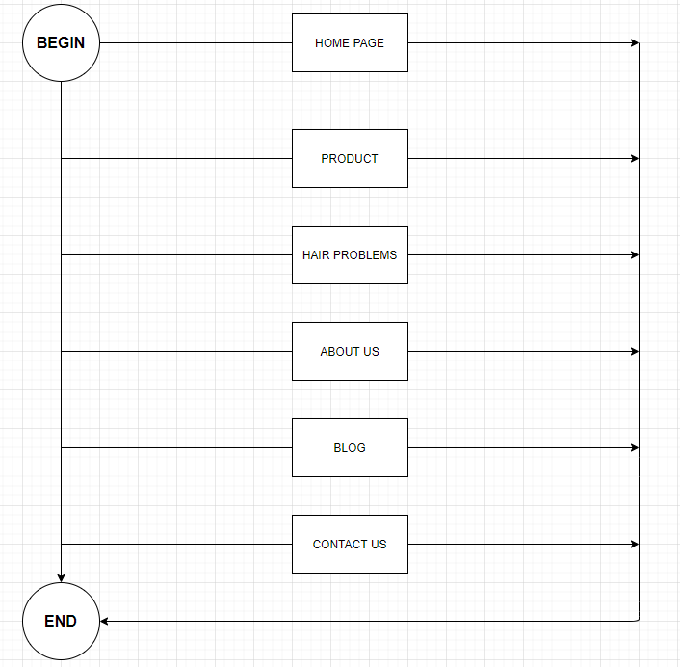



# TASK SHEET REVIEW 1

|  |  |  |  |  |  |  |  |
| --- | --- | --- | --- | --- | --- | --- | --- |
| **Project Ref. No.:**  **eP/Advertisement Portal Management**  **System/01** | | **Project Title:** | **Activity Plan Prepared By:** | **Date of Preparation of Activity Plan:** | | | |
| **Sr.**  **No.** | **Task** | **Actual**  **Start Date** | **Actual Days** | **Team**  **Mate Names** | **Status** |
| 1 | Problem Statement | HAIR CARE | Phat | 11-June-22 | 1 | Phat | Completed |
| 2 | Analysis of HairCare requirements about the website | 14-June-22 | 1 | Dan | Completed |
| 3 | The scope of the work (in brief) | 14-June-22 | 1 | Phat | Completed |
| 4 | Architecture and design of the system | 14-June-22 | 1 | Dan | Completed |
| 5 | Diagram of the website | 14-June-22 | 1 | Phat | Completed |
| 6 | Task Sheet | 14-June-22 | 1 | Dan | Completed |

|  |  |
| --- | --- |
| **Date:** | |
| Signature of Instructor:  **Mr. Le Thanh Nhan** | Signature of Team Leader:    **Le Hoang Thanh Phat** |

# SITE MAP

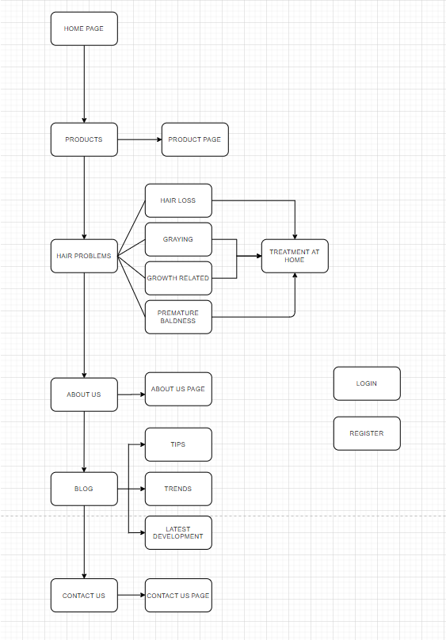

# MOCK OF THE WEBSITE

1. **HOME PAGE**

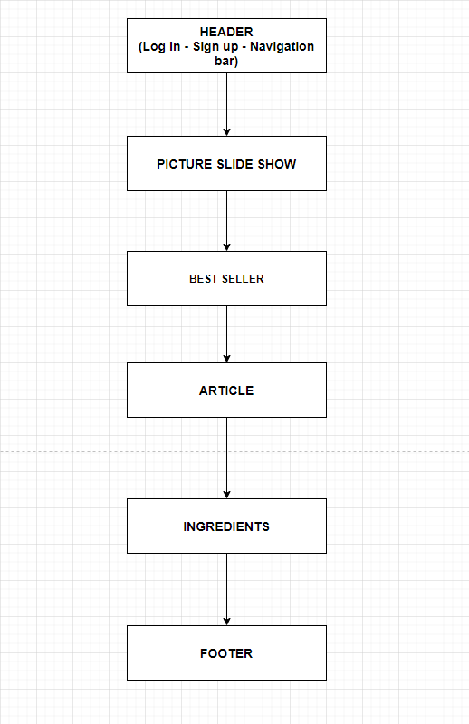

1. **PRODUCTS**

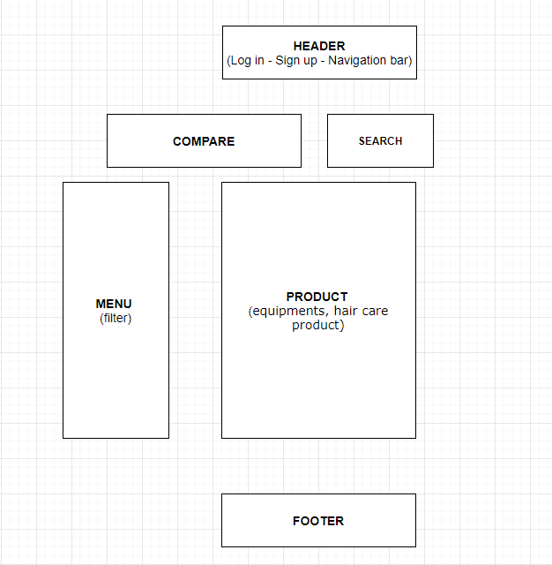

1. **HAIR PROBLEMS**

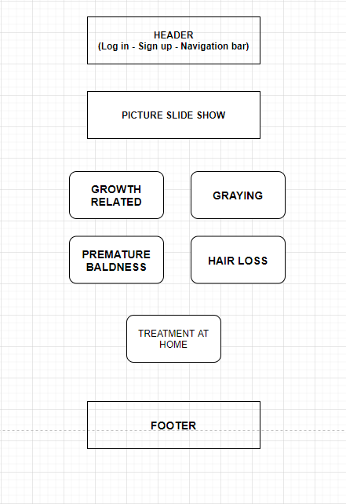

1. **ABOUT US**

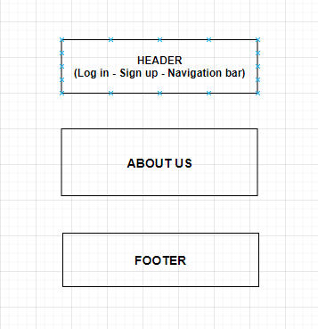

1. **BLOG**

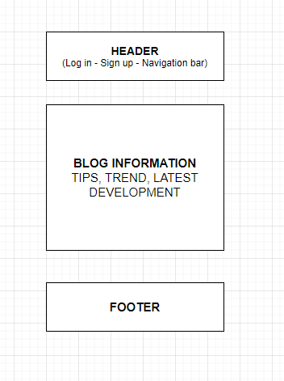

1. **CONTACT US**

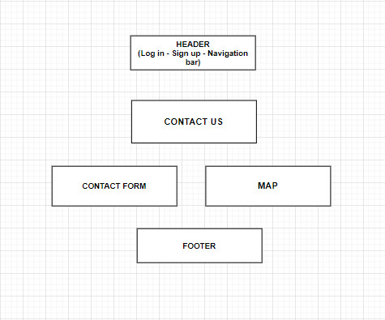

1. **LOG IN**

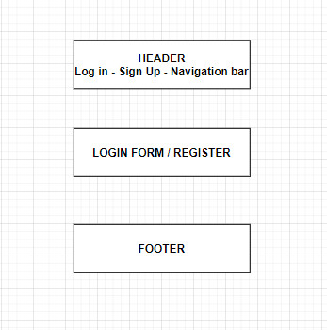

# TASK SHEET REVIEW 2

|  |  |  |  |  |  |  |  |
| --- | --- | --- | --- | --- | --- | --- | --- |
| **Project Ref. No.:**  **eP/Advertisement**  **Portal Management System/01** | | **Project Title:** | **Activity Plan Prepared By:** | **Date of Preparation of Activity Plan:** | | | |
| **Sr.**  **No.** | **Task** | **Actual Start Date** | **Actual Days** | **Team Mate Names** | **Status** |
| 1 | Site map | Hair Care | Phat | 15-June-22 | 1 | Dan | Completed |
| 2 | Mock of the website | 15-June-22 | 2 | Phat | Completed |
| 3 | Task sheet | 15-June-22 | 2 | Phat | Completed |

|  |  |
| --- | --- |
| **Date:** | |
| Signature of Instructor:  **Mr. Le Thanh Nhan** | Signature of Team Leader:  **Le Hoang Thanh Phat** |

# WEBSITE DESCRIPTION

### Home page

1. Description

Home page displays following information:

* Navigation bar.
* Best Seller.
* Some information about hair care
* Ingredients
* Footer

1. Screenshot

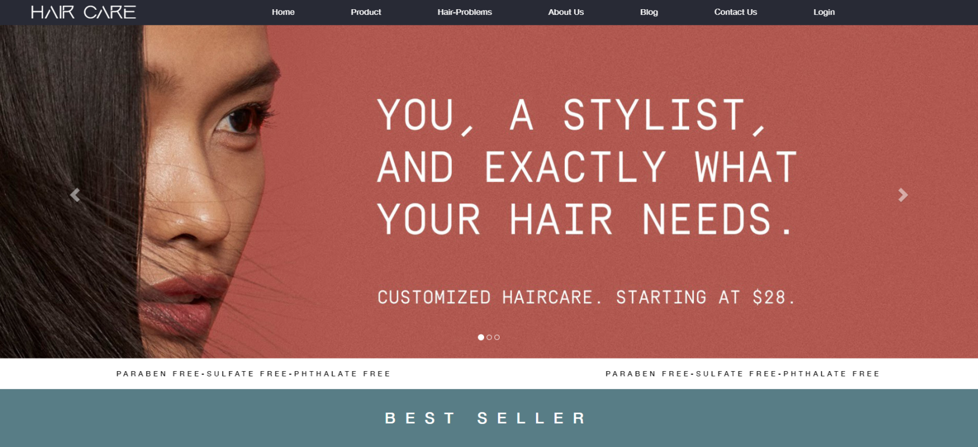

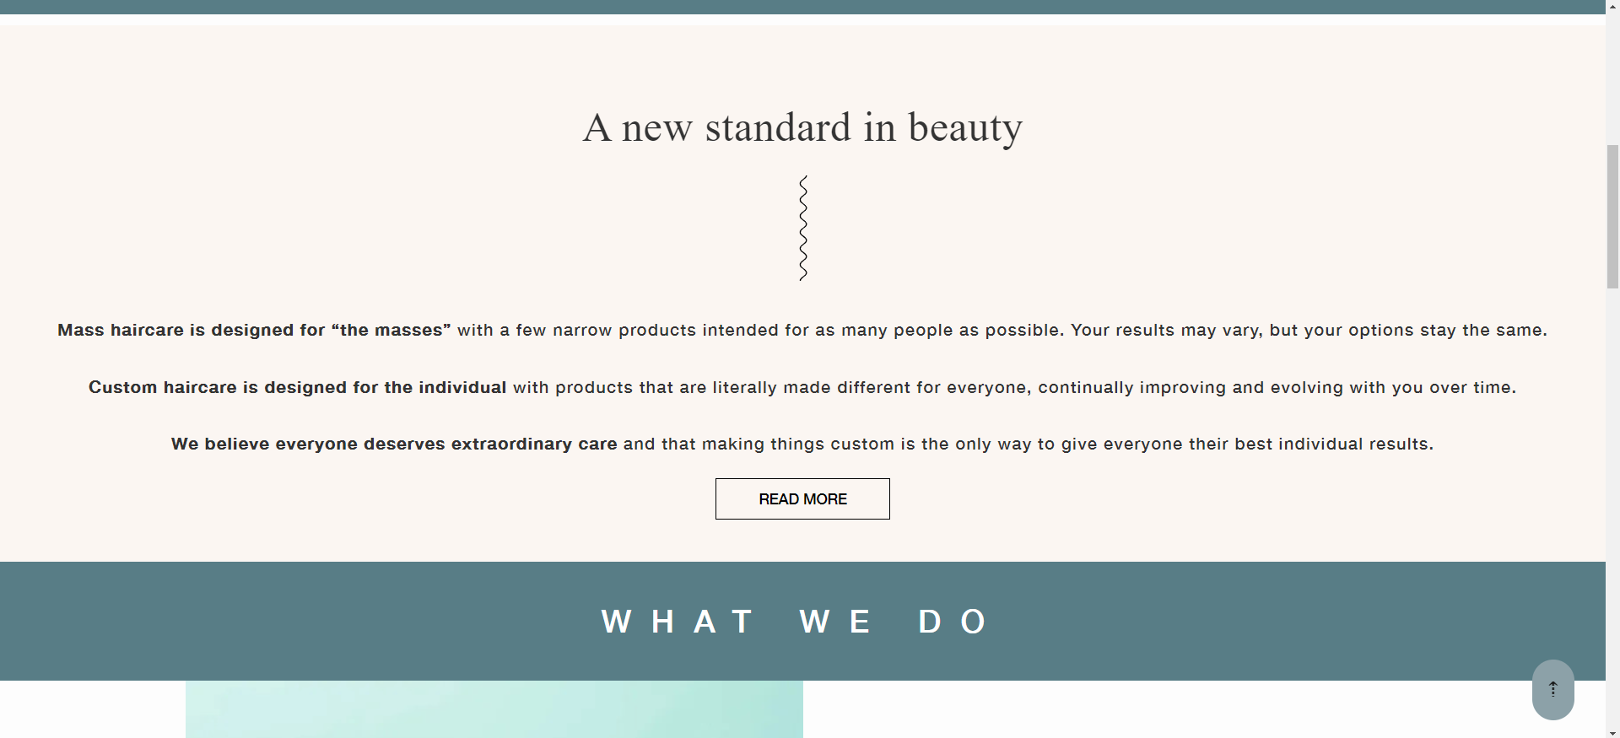

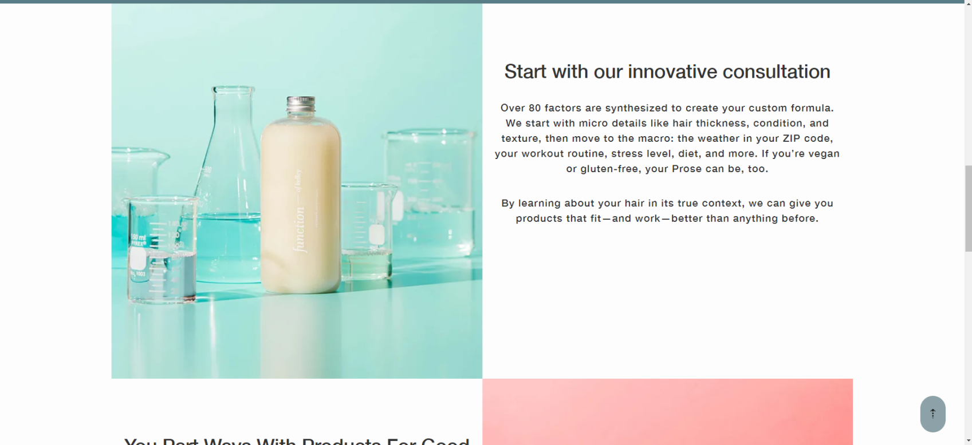

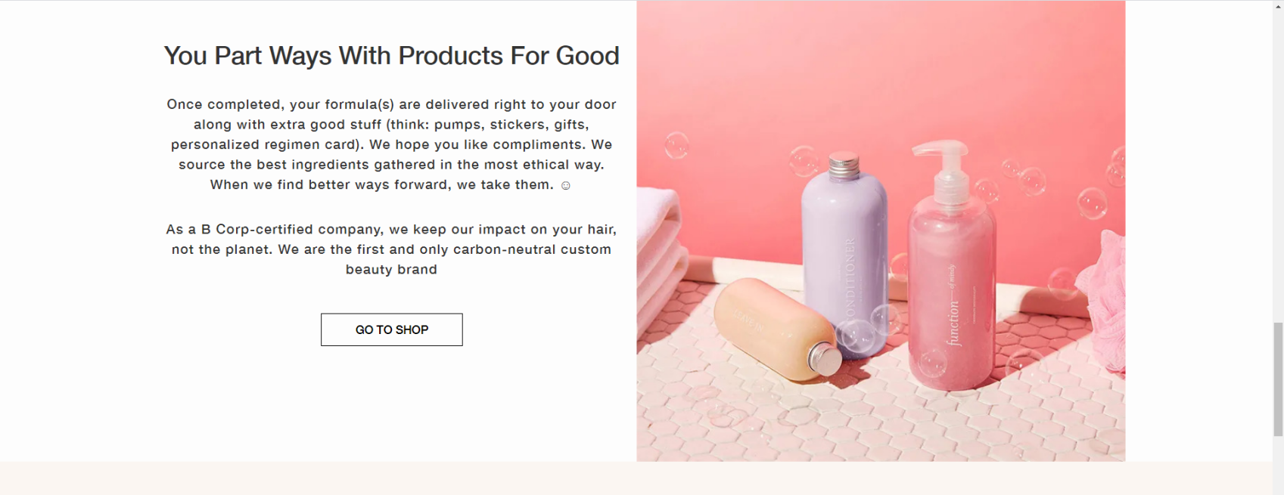

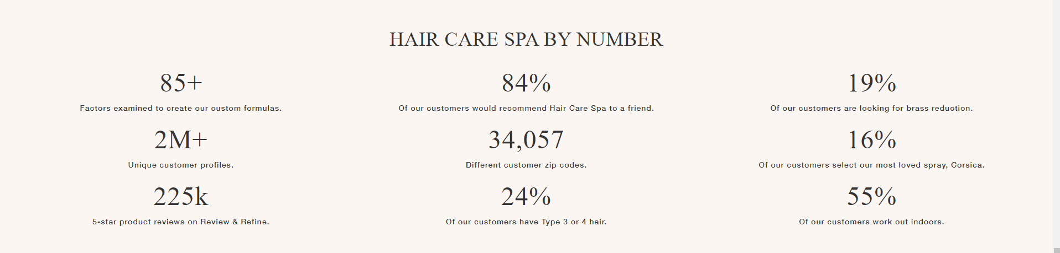

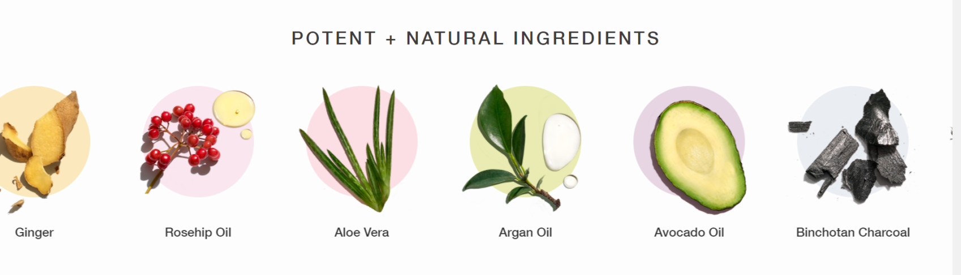



### Product page

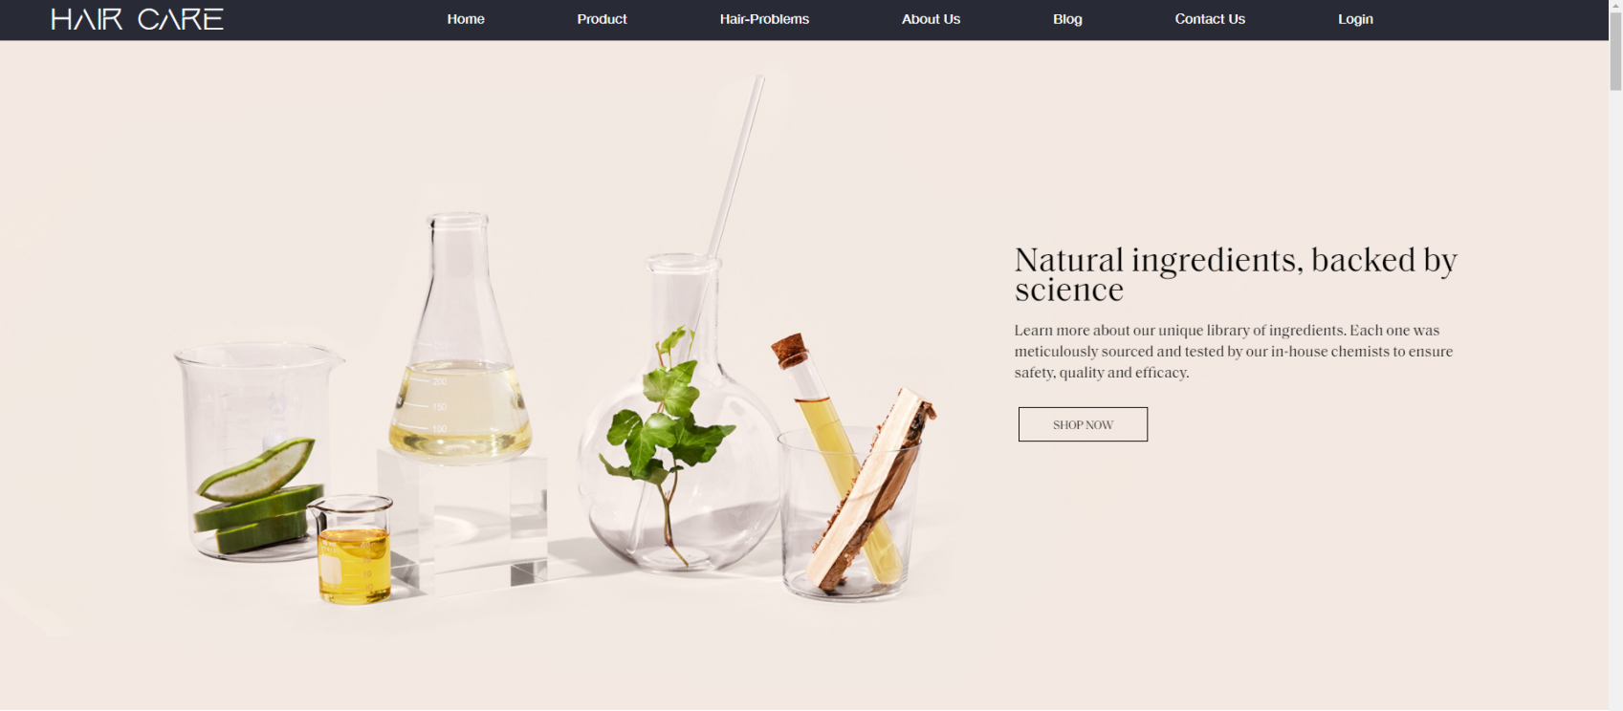

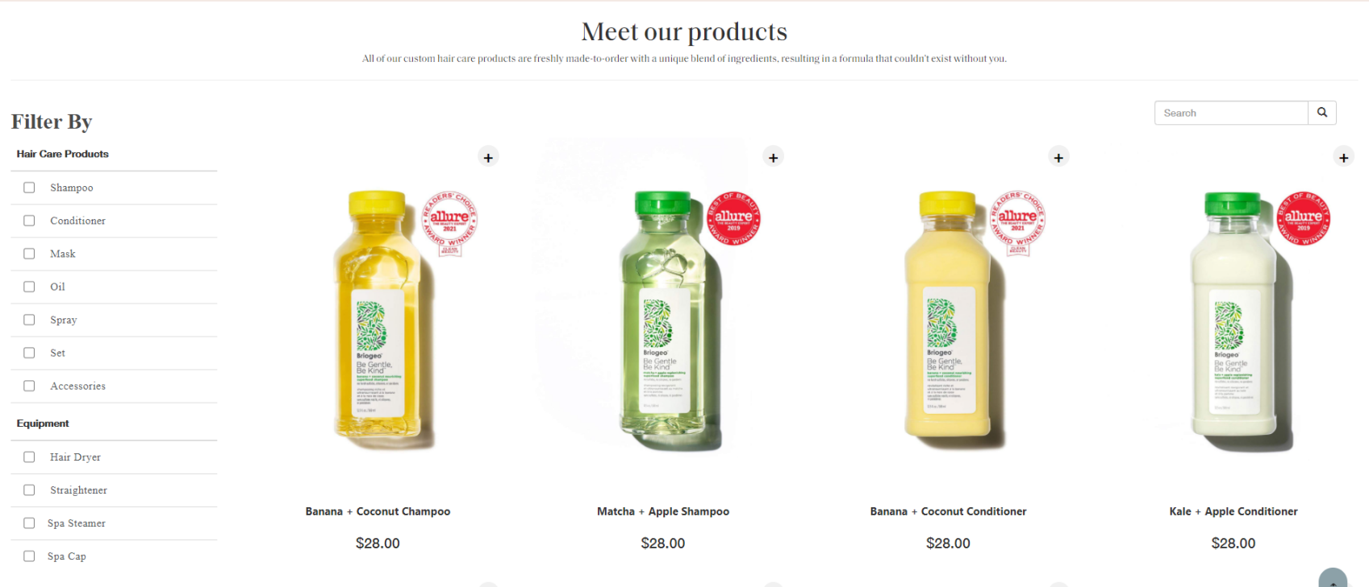



2.1 Comparison

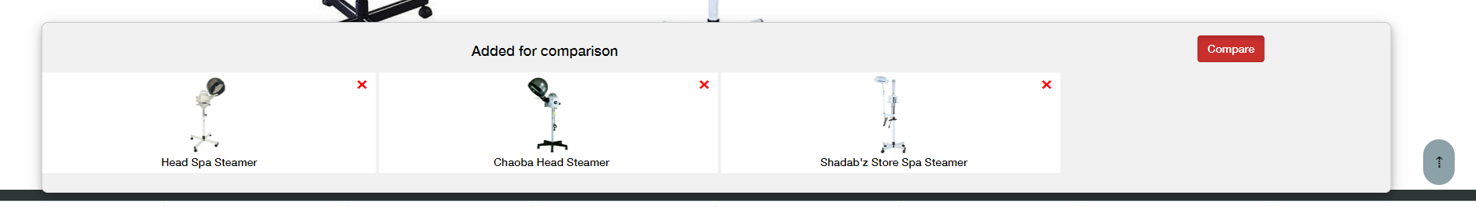

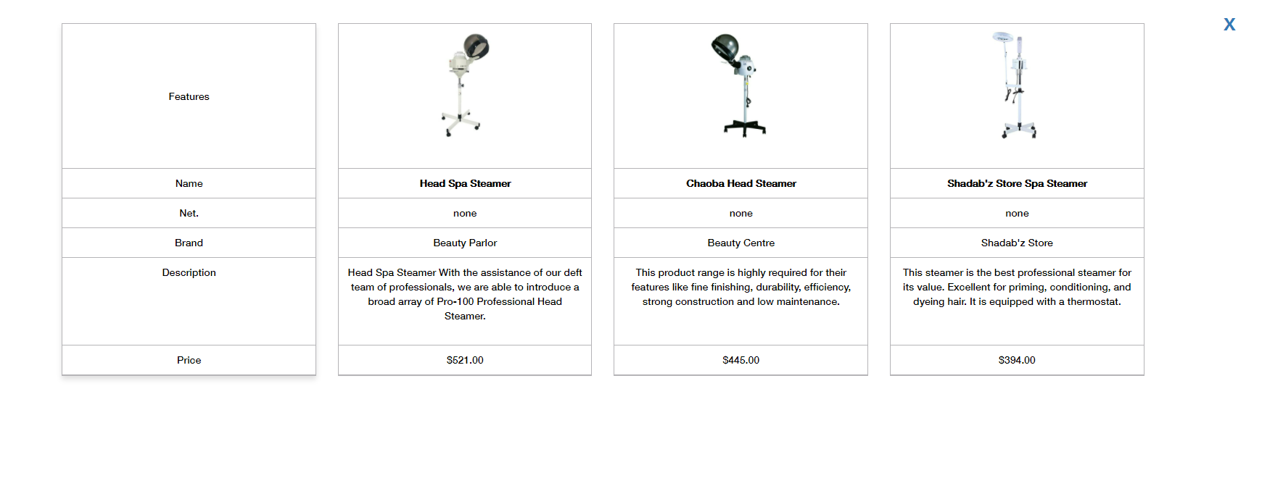

2.2. Modal

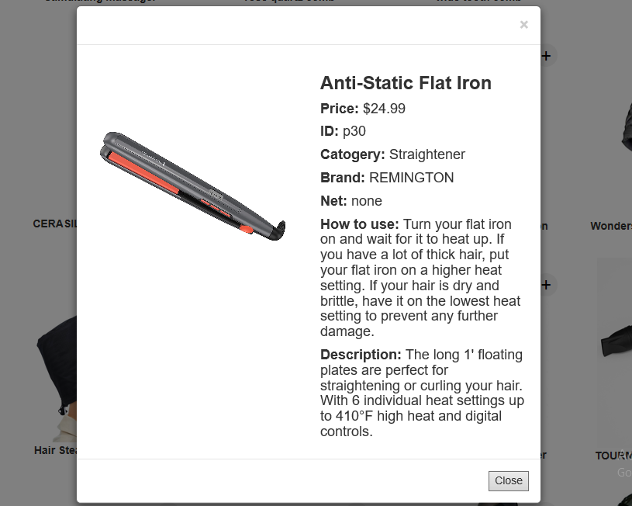

### Hair problems page

3.1. Article about hair problems

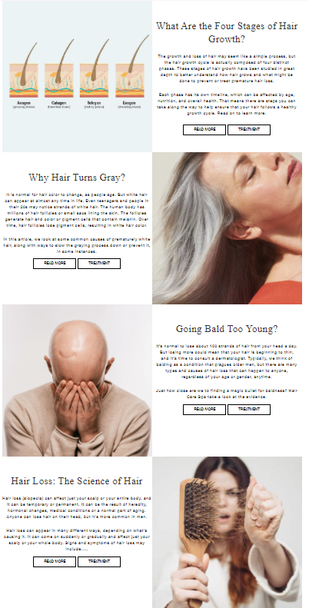

3.2. Treatment at home

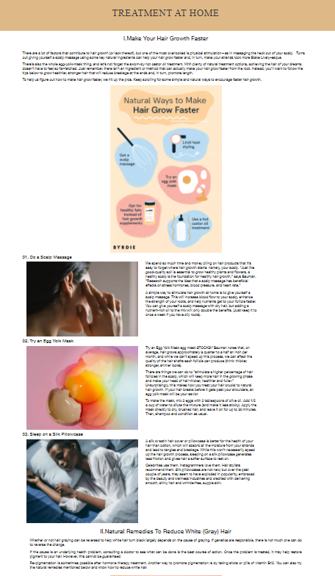

### Blog

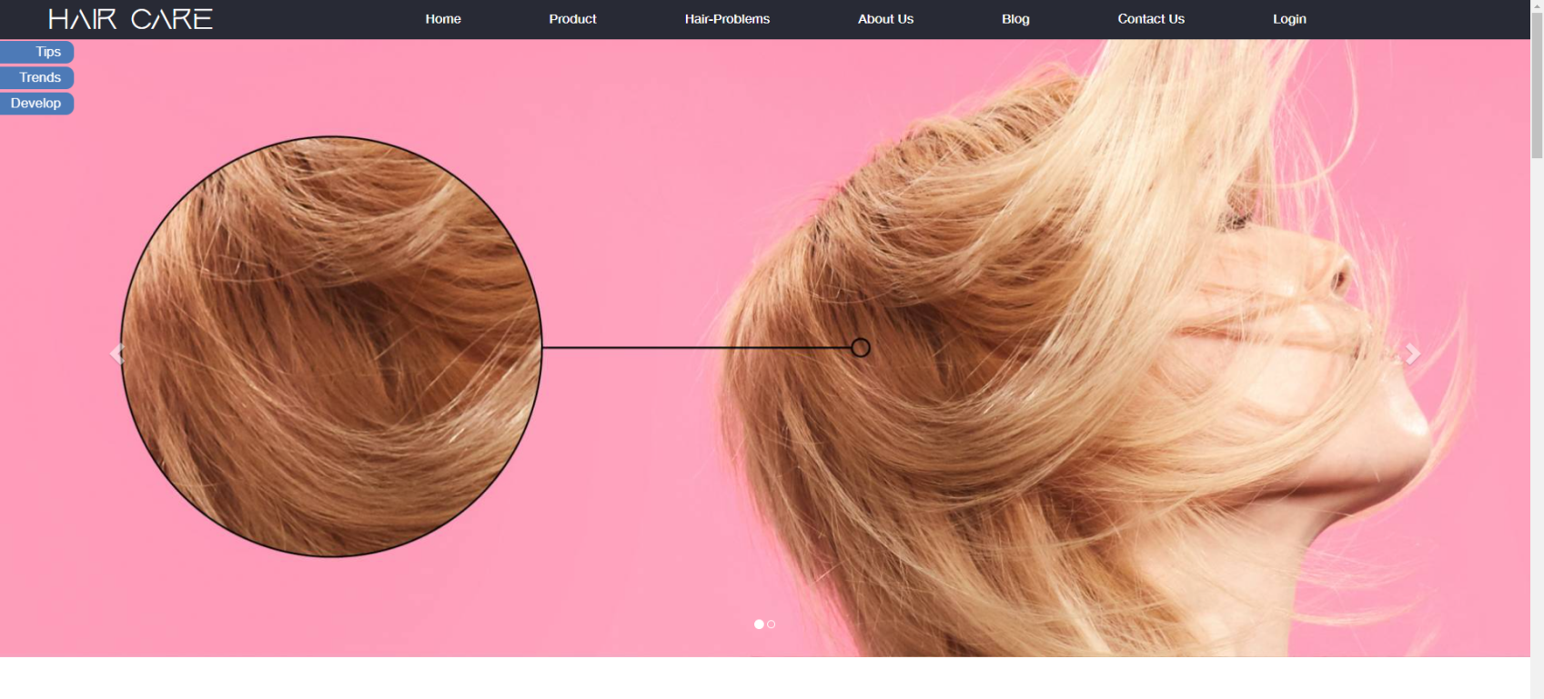

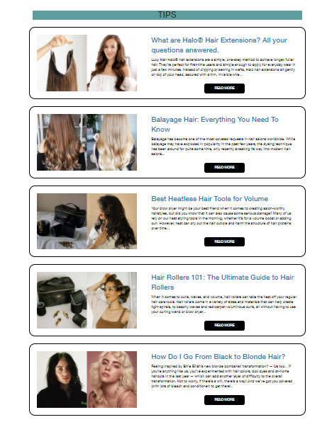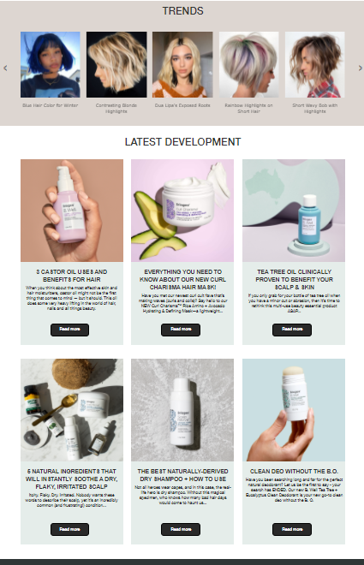

### Contact us

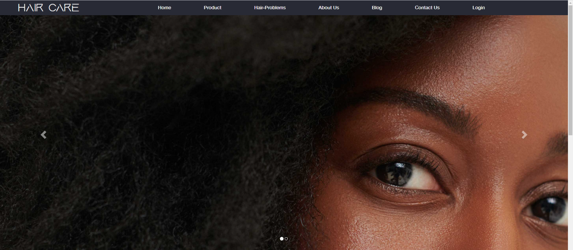

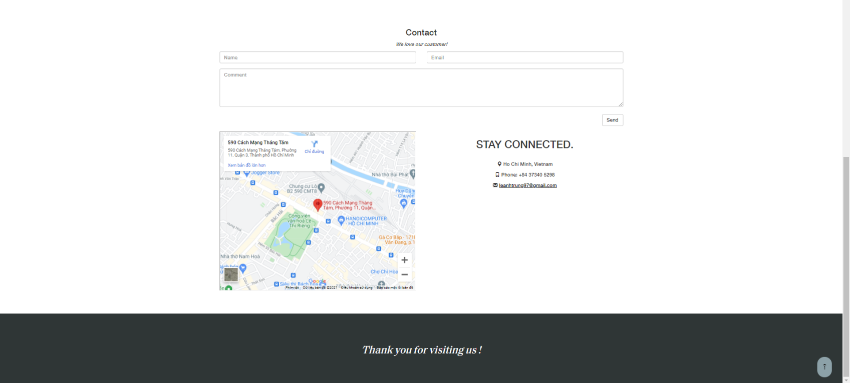

### Login/Register form

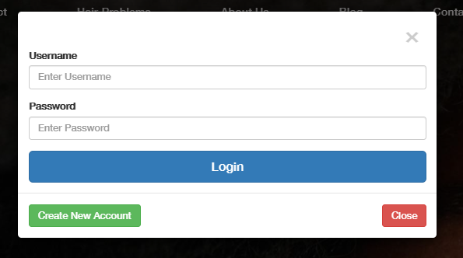  
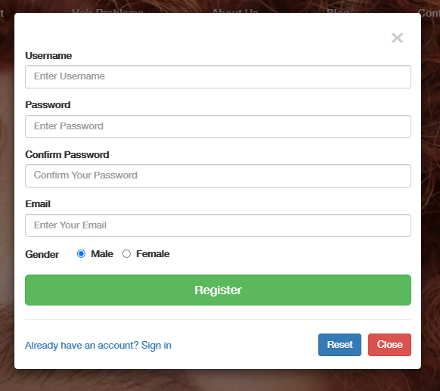

# JAVASRIPT DESCRIPTION

1. Slider - Carousel:

This script used Owl package (carousel) to display the products on the website.

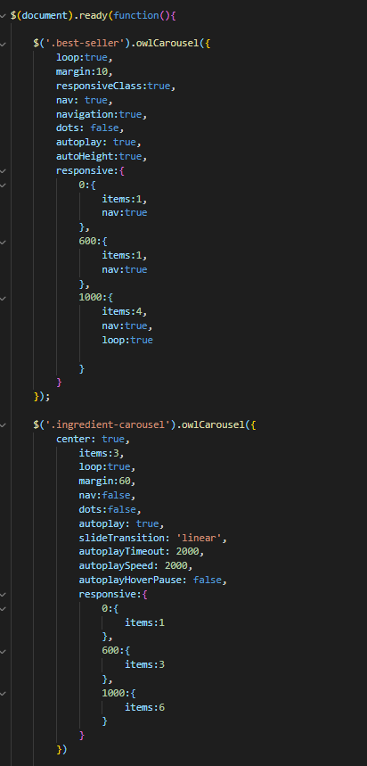

### Login / Resgister Modal:

This script is used for displaying information upon log in or register action, when user click on Create an Account button, remove login modal and show register modal...

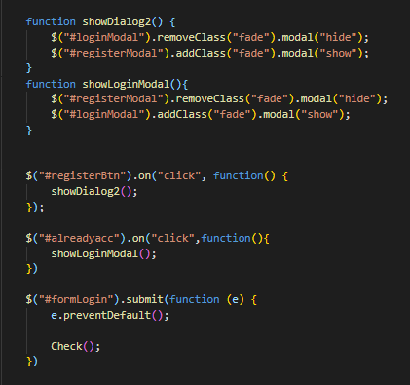

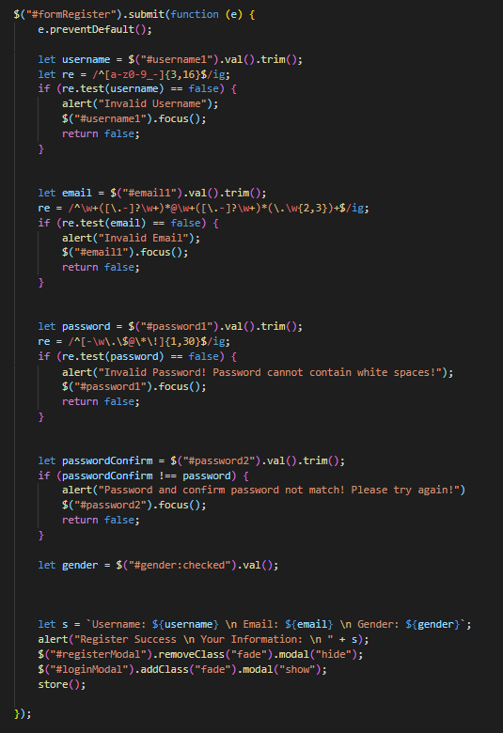

1. Local Storage:

When user register new account, data will save into local storage. If local storage doesn’t exit, the browser will show alert and stop login form.

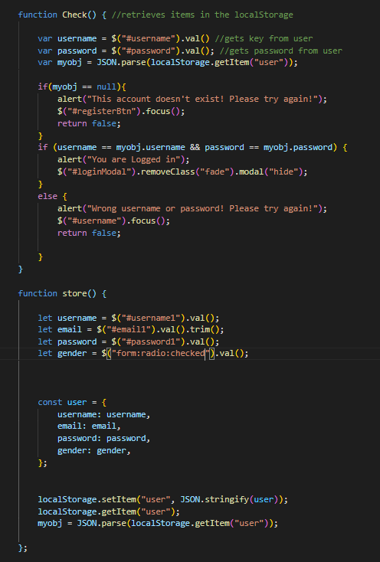

### Go to Top Button:

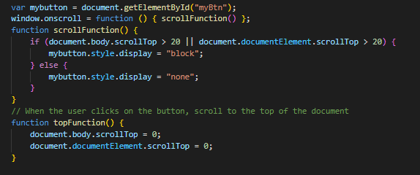

### Load JSON:

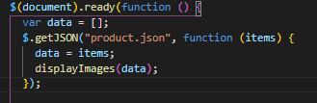  
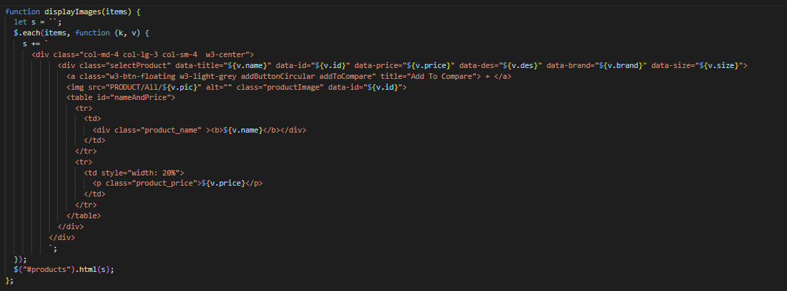

### Form Search:

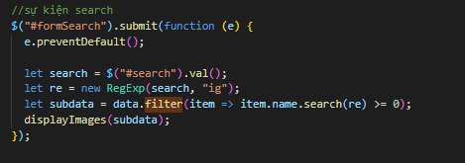

### Filter:

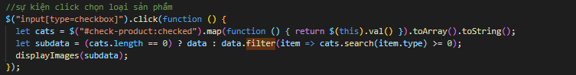

### Show modal when click:

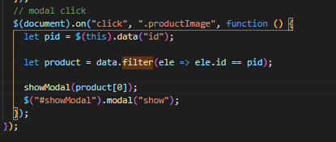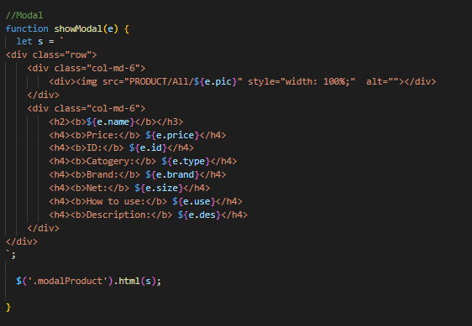

### Comparision:

The comparision allows user select 3 products and push its to panel compare, if select more than 3 products, show alert not allow continue select. When user click compare button, show new modal to compare products selected.

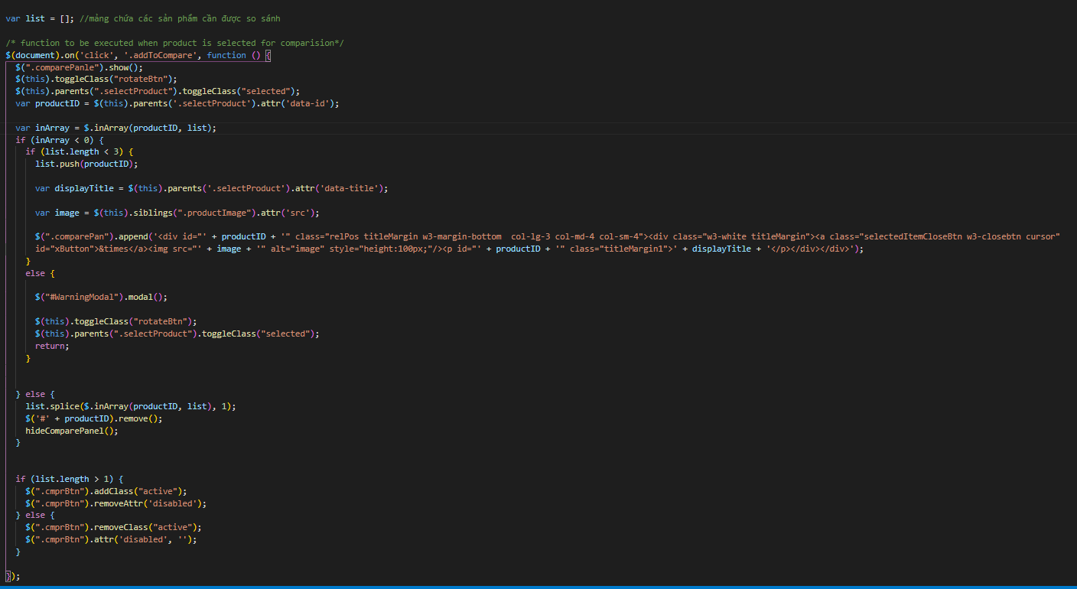  
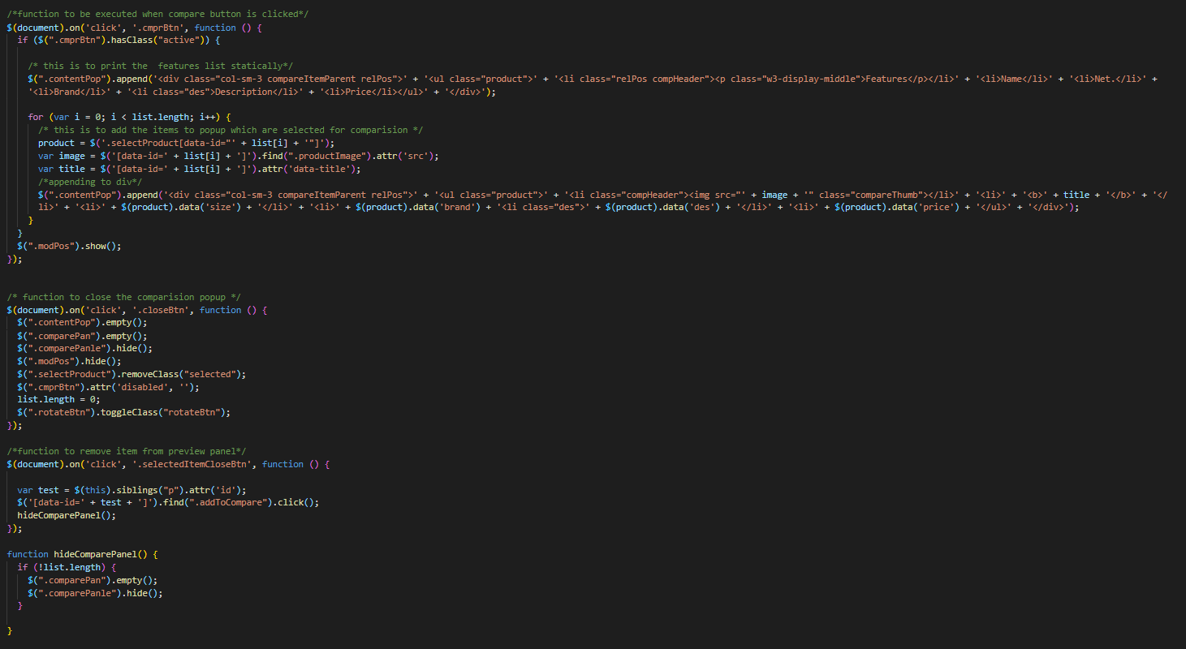

### Scroll into View:

(html): When user click button, the page scroll into article:

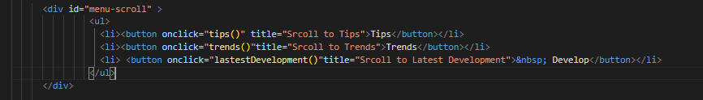

(script)

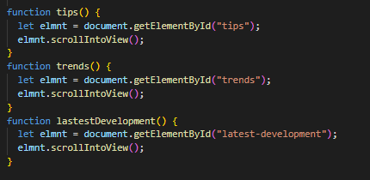

### Form Contact:

Allow user send some message. if they want send mail directly, they can click a link mailto@:

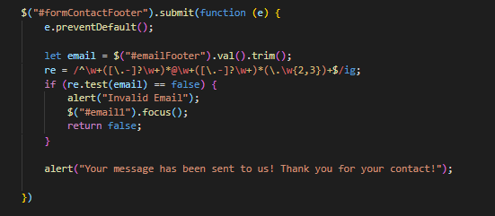

1. **Responsive**

a.The page has responsive feature for small screen device such as smart phone, tablet, laptop, desktop,etc...

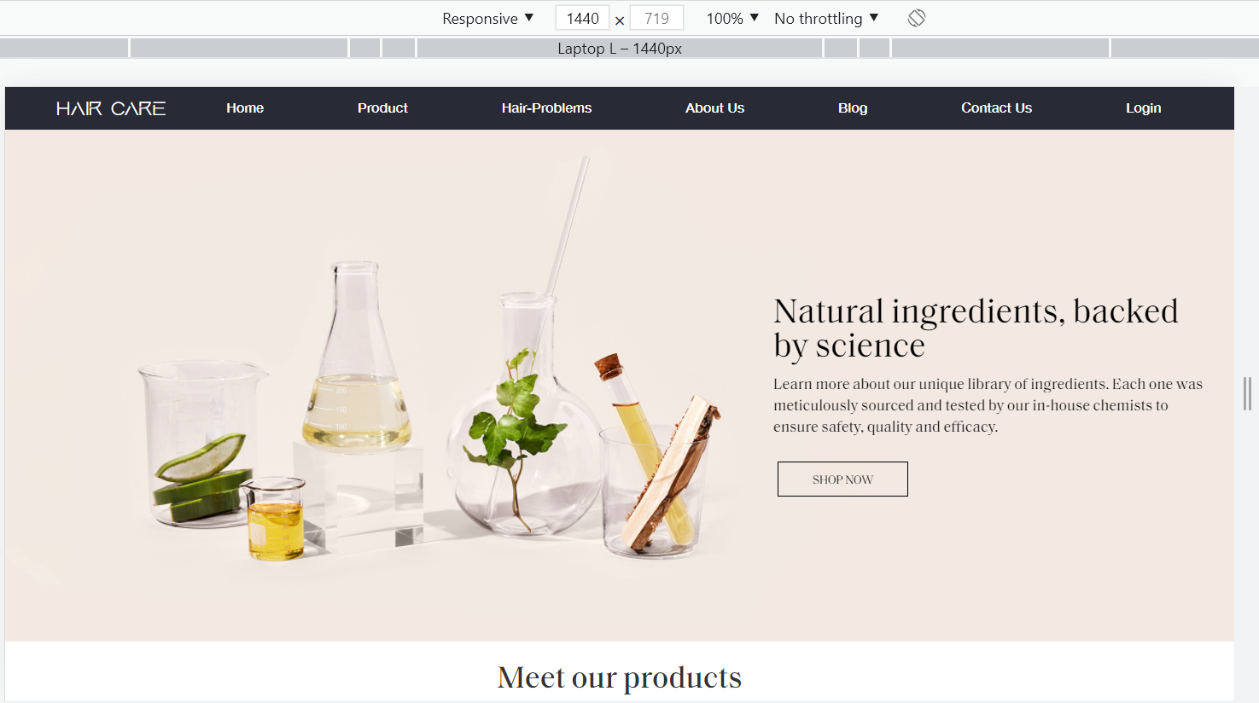

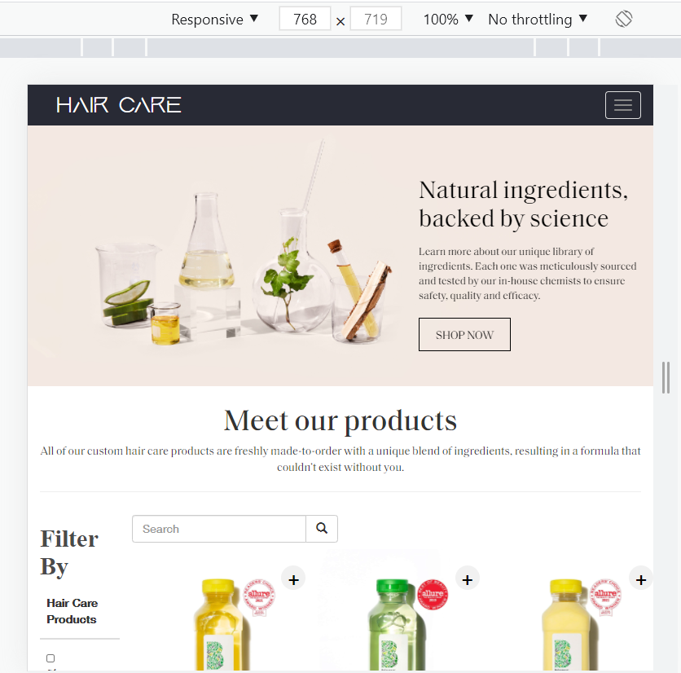

b. Menu Mobile when responsive: (css)

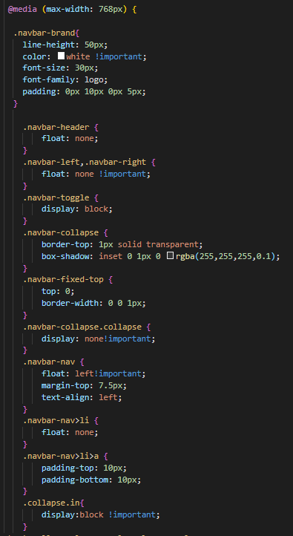

# TASK SHEET REVIEW 3

|  |  |  |  |  |  |  |  |
| --- | --- | --- | --- | --- | --- | --- | --- |
| ***Project Ref. No.:***  ***eP/Advertisement Portal Management System/01*** | | ***Project Title:*** | ***Activity Plan Prepared By:*** | ***Date of Preparation of Activity Plan:*** | | | |
| ***Sr.***  ***No.*** | ***Task*** | ***Actual Start***  ***Date*** | ***Actual Days*** | ***Team Mate***  ***Names*** | ***Status*** |
| *1* | *Home page* | *Hair Care Spa* | *Phat* | 11-June-22 |  | *Dan* | *Completed* |
| *2* | *Shop* | 11-June-22 |  | *Phat* | *Completed* |
| *3* | *Hair Problems* | 11-June-22 |  | *Dan* | *Completed* |
| *4* | *Blog* | 11-June-22 |  | *Dan* | *Completed* |
| *5* | *About us* | 11-June-22 |  | *Phat* | *Completed* |
| *6* | *Contact us* | 11-June-22 |  | *Phat* | *Completed* |
| *7* | *Log in* | 11-June-22 |  | *Dan* | *Completed* |
| *8* | *Register* | 11-June-22 |  | *Dan* | *Completed* |
| *10* | *Javascript* |  |  | 11-June-22 |  | *Dam* | *Completed* |
| *11* | *Responsive* |  |  | 11-June-22 |  | *Phat* | *Completed* |
| *13* | *User Guide* |  |  | 11-June-22 |  | *Phat* | *Completed* |

|  |  |
| --- | --- |
| **Date:** | |
| Signature of Instructor:  **Mr. Le Thanh Nhan** | Signature of Team Leader:  **Le Hoang Thanh Phat** |